Coach: Date: Training Length:

Topic: Technical/Tactical:

Organization

**Activity 1**

**Activity 2**

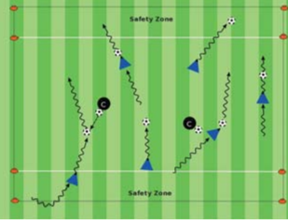

Objectives: Players get to play the game. Team

w/the ball works to get past opponents and score

goals.

Organization: Set up 2-3 15W x 20L fields w/a

goal at each end. As players arrive to the field

start to play 2v2, 3v3, up to 4v4 games.

Time: 4 games of 2 mins, 30 sec rest, activity

duration is 10 min.

Rules: Start w/a kick off. Out of bounds, pass or

dribble ball in. Allow for periods of free play

Key Words: Look up, find an opening, shield (hide) the ball, fake the defender, go to goal.

Guided Questions: What should you instruct players to do when confronted by a defender? When do you make the activity more challenging?

Answers: Show players how to keep the ball close & shield it while dribbling (put their body between ball & defender). Explain how to use moves & fakes (change of direction & speed) to get around and past the defender. When players have repeatedly demonstrated

successful dribbling & running with the ball past defenders to score

**Key Coaching Points**

**Organization**

**Warm Up**

Key Words: Go to goal, head up, find an

opening (through players) to goal, go score.

Guided Questions: How can you help make the

game fun? What can you do to keep the game

simple and less confusing for children?

Answers: Be encouraging by giving positive

reinforcement for successful technical (dribbling

& shooting) accomplishment. Keep coaching

instruction to a minimum.

**Key Coaching Points**

**Organization**

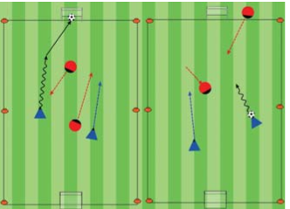

Tactical/Technical:

**Key Coaching Points**

**Organization**

**Game**

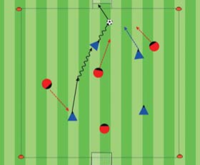

Key Words: Look up, find an opening, shield (hide) the ball, fake the defender, go to goal.

Guided Questions: What should you instruct players to do when confronted by a defender? When do you make the activity more challenging?

Answers: Show players how to keep the ball close & shield it while dribbling (put their body between ball & defender). Explain how to use moves & fakes (change of direction & speed) to get around and past the defender. When players have repeatedly demonstrated

successful dribbling & running with the ball past defenders to score

Objective: Players dribble across the field, past opponents and through a cone goal to score.

Organization: In 20Wx25L yd grid w/a 5yd end zone off the endline & 3 small goals on the endlines. (see diagram) Every player has a ball. 2 defenders without a ball.

Rules: Players w/ a ball start inside an end zone. On coach's "Go!" players try to dribble across to the other end zone & dribble through a goal. Defenders can only steal a ball outside the end zones. If a defender steals a ball and dribbles it into a goal, roles switch

Organization: Set up like core activity,

no goals, & coaches are defenders w/ball

in hand. Players dribble past coaches to

the opposite safety zone.

Rules: Every player with a ball. Start on

coach's "Go!". Dribble to other safety zone

w/out your ball being tagged by a coach's

ball dropped on yours. If so, switch roles.

**Key Coaching Points**

**Organization**

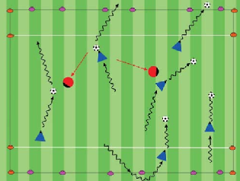

Key Words: Shield the ball, keep it close, try a move, find the opening to score.

Guided Questions: How do you know players

understood your instructions? How do you know that they have improved?

Answers: Players can demonstrate or "show you" their moves or fakes & how to shield the ball. Players are "taking on" opponents 1v1 and dribbling past them to score goals

Objective: Players try to dribble forward past

opponents to score goals.

Organization: On a 25W x 35L field w/ a small

goal at each end. Play 4v4.

Time: Play a 30 min game. Two 12 min halves

with 3 min of rest after each half.

Rules: All modified 4v4 rules apply