Coach: Date: Training Length:

Topic: Technical/Tactical:

Organization

**The Cat In The Hat vs Things 1 & 2**

**Tiggers vs Rabbits**

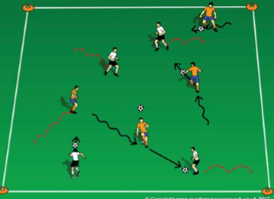

Set up two 15W x 20L fields with a goal at each end. When practice is scheduled to start and as soon as 2 players arrive, start playing a game. The game will start as 1v1. When the next player arrives, the game is 2v1 then 2v2 up to 3v3. After 1 field is at 3v3, start the second game on the field next to it.

Observation: are the players able to avoid the Things? Technical Tip: point the toe down and with their shoe laces, push the ball in front of themselves and into space away from the Things. Touches can be bigger if space is open.

**Key Coaching Points**

**Organization**

**3v3 Games**

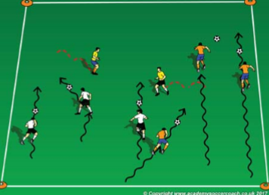

Is the activity organized? (cones, scrimmage vests, balls, players, goals) Is it reality-based? (does it look like a soccer game?) Is there repetition? (Focus on dribbling & striking the ball (session themes) Is it challenging? (Players should be engaged not frustrated or bored) Is there coaching? (Positive reinforcement of dribbling)

**Key Coaching Points**

**Organization**

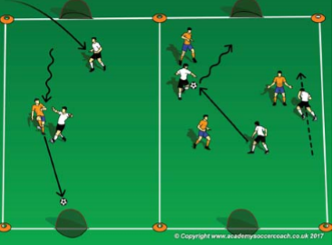

Tactical/Technical:

**Key Coaching Points**

**Organization**

**4v4 Game**

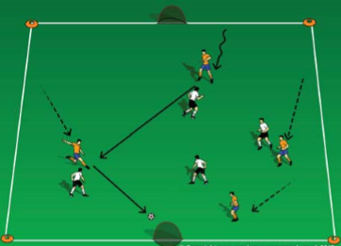

Observation: are the Rabbits able to strike the ball with the inside of their foot or laces? Technical Tip: point the toe down to strike with the laces or point the toe to the side and up to use the instep.

In a 15W x 20L grid, select 2 players to start as Thing 1 & Thing 2; they do not need a soccer ball and can only hop around the field. The rest of the players start at 1 end line with a soccer ball; they are Cats in Hats. On the coach's command, the Cats try to get across the field without getting tagged by a Thing. If a dribbler gets tagged, they become a Thing also. (Coaches can start as Things or Cats if needed)

In a 15W x 20L grid, 2 cone goals on each end line, the coach will divide the group into 2 teams; 1 team is the Tiggers and the other is Rabbits. The Tiggers start without a soccer ball and can only hop (or skip). The Rabbits start with a soccer ball each and try to hit the Tiggers below their knees. When a Rabbit hits a Tigger, they switch roles. Which players can last the longest as Tiggers?

**Key Coaching Points**

**Organization**

Observation: do the players strike the ball with a surface other than the toe? Technical Tip: encourage the players to move the ball slightly to the side and away from their body so they have room to rotate the foot for other surfaces.

In a 20W x 30L field and a small goal on each end line, play a 4v4 game. If the roster & attendance is larger than 8, divide the group into 2 equal team, set up a second field and play 2 games at the same time. Take plenty of breaks for rest and water.