Coach: Date: Training Length:

Topic: Technical/Tactical:

Organization

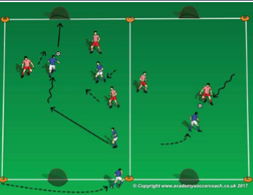

**(4 Surfaces)**

**(Saber Tooth Squirrels)**

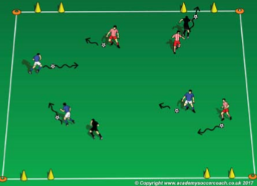

Set up two 15W x 20L fields with a goal at each end. When practice is scheduled to start and as soon as 2 players arrive, start playing a game. The game will start as 1v1. When the next player arrives, the game is 2v1 then 2v2 up to 3v3. After 1 field is at 3v3, start the second game on the field next to it.

Observation: are the players keeping the ball close when using the inside or outside of the foot? Technical Tip: use soft touches (baby touches) when using outside/inside

**Key Coaching Points**

**Organization**

**Warm Up (3v3 Games)**

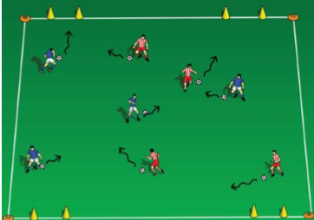

Is the activity organized? (cones, scrimmage vests, balls, players, goals) Is it reality-based (does it look like a soccer game?) Is there repetition? (Focus on dribbling (session theme) Is it challenging? (Players should be engaged not frustrated or bored) Is there coaching? (Positive reinforcement of dribbling)

**Key Coaching Points**

**Organization**

Tactical/Technical:

**Key Coaching Points**

**Organization**

**4v4 Game**

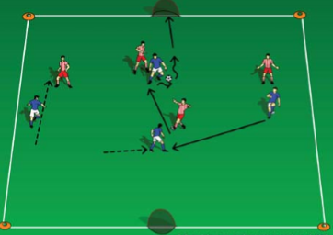

Observation: are the players able to avoid the Scrats? Technical Tip: keep your head up to find the Scrats. Dribble away from the Scrats with bigger touches on the ball.

In a 15W x 20L grid, 2 cone goals on each end line & each player with a soccer ball: The players dribble their soccer ball in a specific pattern: outside right foot (pinky toe)-inside right foot (big toe)-repeat with the left foot. On the coach's command (or whistle), the players will dribble their ball as fast as they can to any of the 4 goals and dribble through it.

In a 15W x 20L grid, 2 cone goals on each end line, select 2 players to be Scrats, all other players have a soccer ball: The players dribble their soccer ball (acorn) anywhere in the grid and avoid the Scrats. The Scrats try to steal their acorn and hide it in any of the 4 goals. The dribblers can try to steal their ball back and even steal it from the goal. Scrats get 1 point for every acorn they hide in a goal.

**Key Coaching Points**

**Organization**

Observation: do the players keep the ball close when in a crowd and bigger touches in open space? Technical Tip: soft touches (baby touches) in a crowd and push the ball further in front when space is open.

In a 20W x 30L field and a small goal on each end line, play a 4v4 game. If the roster & attendance is larger than 8, divide the group into 2 equal team, set up a second field and play 2 games at the same time. Take plenty of breaks for rest and water.