Coach: Date: Training Length:

Topic: Technical/Tactical:

Organization

**Activity 1**

**Activity 2**

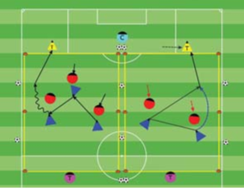

Objective: To get players into a game as soon as they arrive to practice and outscore the opponent.

Organization: Set up two or more 20Wx30L fields with at goals at each end. As the players arrive, play 1v1, 2v1,

2v3, up to 4v4.

Time: 3 games of 2.5 minutes, 30 second rest,

for a total of 9 minutes

Rules: Out of bounds - Pass or dribble the ball in

Key Words: Penetrate, Make diagonal passes, Get on the move (Behind, Forward and to the Sides of the ball), Be available for a pass

Guided Questions:

- If confronted by one defender in the flank with space behind what

would you like the player with the ball to do?

- What if a another defender comes to help?

Answers: The player should dribble at the defender and take him on a 1v1.

Then another attacker should assist the dribbler as an option to a

pass or combination play through the opening between defenders.

**Key Coaching Points**

**Organization**

**Warm Up**

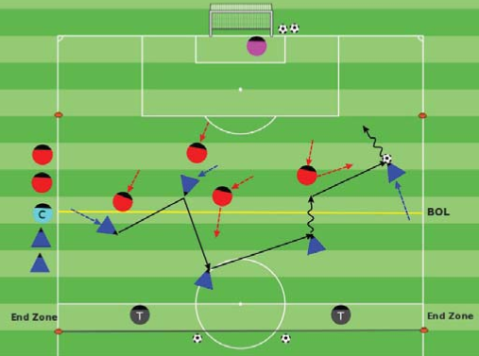

Key Words: Penetrate, Make diagonal passes,

Be available to receive a pass.

Guided Questions:

- What can you do to balance the teams if they

are lopsided?

- Cant go forward with the ball, what do we need

to do?

Answer:

Stop play and reshuffle the teams.

We need to possess to find or create an opening.

**Key Coaching Points**

**Organization**

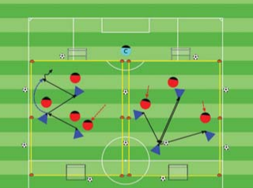

Tactical/Technical:

**Key Coaching Points**

**Organization**

**Game**

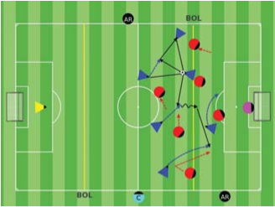

Key Words: Penetrate, Make diagonal passes, Get on the move (Behind, Forward and to the Sides of the ball), Be available for a pass

Guided Questions:

- If confronted by one defender in the flank with space behind what

would you like the player with the ball to do?

- What if a another defender comes to help?

Answers: The player should dribble at the defender and take him on a 1v1.

Then another attacker should assist the dribbler as an option to a

pass or combination play through the opening between defenders.

Objective: To unbalance and disorganize the opponent finding or creating an

opening to pass or dribble forward to create scoring chances.

Organization: Play 5v5 in a 40Wx35L with a regular goal and target players in the

end zone.

- Change the targets every interval.

Scoring: Blue team scores in the regular goal, Red by passing to the targets or dribbling into the end zone.

Rules:All FIFA Rules Apply

Organization:

- Play 3v3 or 2v2 in a 20Wx30L with a

target player in each end line.

- Change target every interval.

Scoring: Blue scores by passing to

the triangles and Red to the circles.

Rules: Pass or dribble in.

**Key Coaching Points**

**Organization**

Key Words:

Penetrate, Make diagonal passes,

Get on the move (Behind, Forward and to the

Sides of the ball), Be available to receive a pass.

Guided Question

- What are the players doing that shows

understanding and possible transfer to the

game?

Answer:

They are passing (diagonally) forward,

backwards and sideways to move the opponent

and create or find an opening to go forward.

Objective:

To unbalance and disorganize the opponent by

passing and dribbling in the opponent's half in

order to create scoring chances.

Organization:

- Make two equal teams with the players in

practice, play in a 40Wx60L field with goals.

Time: 2 halves of 13 minutes, 2 minutes rest for

a total of 30 minutes.

Rules: All FIFA Rules Apply.